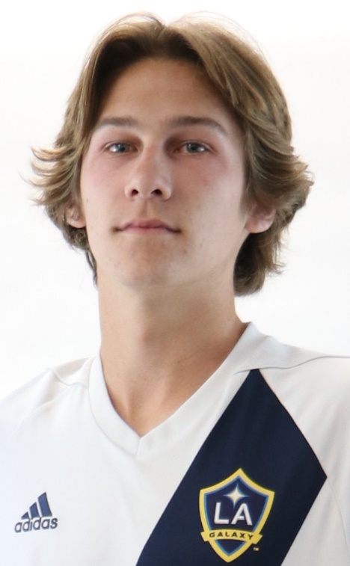

Ben Fraser - 2021 Scholarship Recipient

Ben reports that soccer has been his passion since he was young, and it continues to be so. He has been a leader on and off the field and embraces the team aspect saying he feels he has learned many life lessons from being a good teammate!

Ben was born with a visual condition called strabismus, a neurological disorder where both eyes cannot align simultaneously. As a result, he struggled with crossed eyes and poor depth perception, both of which challenges him as a competitive soccer player as his visual condition made it difficult to follow ball movements. He never allowed that to stop him from trying to work to be the best player he could be. Despite his visual limitation he has been captain of his Club and High School teams and won the 2018 Davis Legacy Team of the Tournament, 2018 San Dieguito Academy Defender of the Year, 2020 San Dieguito Academy MVP and the 2019 National Cup Championship!

In his community, Ben is the Director of Champions League which is dedicated to teaching kids with special needs. After two years working as a volunteer, he became Director of the program. For the program's teen volunteers, some who had never worked with athletes with special needs, it was a great experience allowing them to form a real connection with someone different from them. And most importantly, for the athletes, it gives them the experience of playing soccer. In addition to the experience with Champions League, Ben has also worked for the Cardiff Mustangs training and recreational camps, encouraging and sharing his passion for the game with younger players.

Ben’s plans for next year include playing soccer for Chapman University, a Division 3 school in Orange County.

