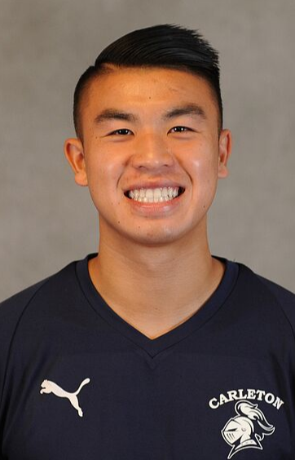

Daniel Zin
Holly’s version:
Daniel Zin is a continuing Gregg Garon Scholarship Winner. Daniel is attending Carleton College in Northfield, MN. Daniel has been recruited into student government where he was elected Class Representative for the Class of 2021. In addition, he was selected to be on the Commencement and Honorary Degree Committee as part of the Carleton Student Association and co-hosts a weekly radio show for Carleton College Radio Station. This past summer he completed an internship with the Law Firm of Autumn Moody where he assisted the team in the development of marketing material and provided administrative support. He found it to be a great learning opportunity and work experience in the legal profession.

