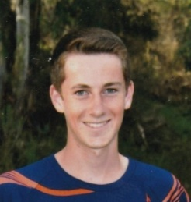

Joey Arnold - played for Poway High School, Poway Vaqueros, and SDSC. Joey wrote that he didn't play competitive soccer until 7th grade, but has worked hard to improve his game. His hard work paid off. . and he was captain of his Varsity team this year. He loves to give back to soccer, is a Grade 8 referee, has his E Coaching license and volunteers with TOPS Soccer. He plans to attend a 4 year university and major in accounting or international business.

