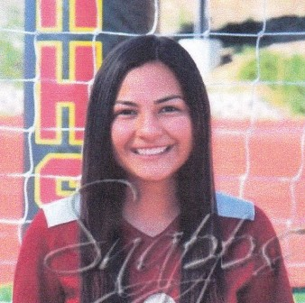

Melissa Sanchez - graduated from Mission Hills High School, and played with San Marcos Matrix. Melissa has played soccer since she was 4 years old. Soccer has led her to form close knit bonds with friends and coaches. She plans to attend CSUSM and major in psychology or biology. She will be the first generation in her family to attend college.

