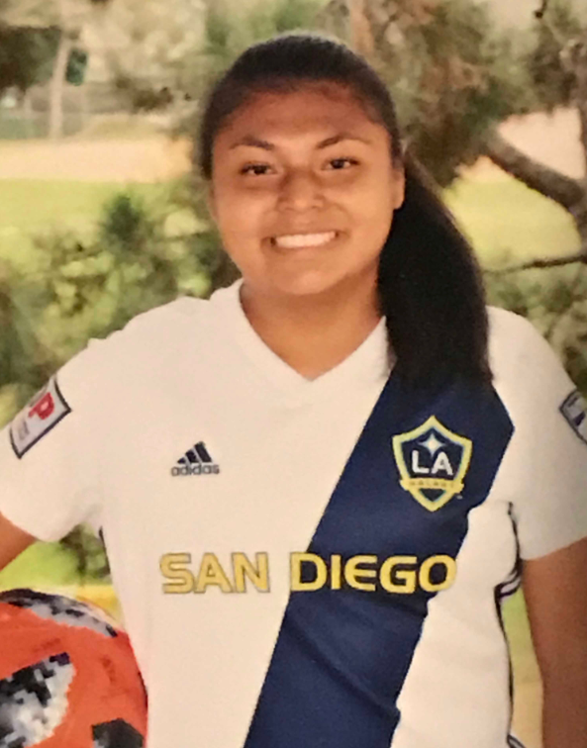

Michelle Diaz Hernandez

Michelle Diaz Hernandez is a special young woman who is most deserving of the Gregg Garon Scholarship. Michelle has overcome a number of health and personal issues to develop into a premiere soccer player, excellent team member and leader. She was able to give back to her community as an assistant coach for a younger team. She now plans to go onto a four-year university to major in Sports Management or become a full-time soccer coach. It is a pleasure to help Michelle achieve her goals with this scholarship.

