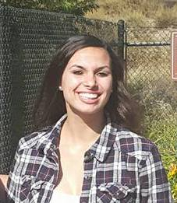
Rachael Camara - is one of our two "continuing" awardees. She has completed her first year at Miramar and plans to transfer to SDSU. She is first generation in her family to attend college . .and we want to support her continued success. Rachael graduated from Westview High School in 2015. Her high school coach wrote, " She has a true passion for the game (whether playing or supporting her team when injured). She wants to be on at all costs!

