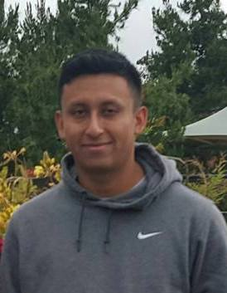
David Venegas - was awarded a scholarship as one of our two "continuing" awardees - he has completed studies at Miramar and is transferring to Regis College in Boston David is the first generation in her family to attend college . .and has been highly successful so far. He has achieved a 3.8 GPA and continued to play soccer. We are pleased to have awarded him this third year of scholarship support. . and hope he does great at the next level!

